**Lab7 - Guideline**

DNS role; C/S architecture, UDP port 53

DNS Namespace

DNS Components

forward query

reverse queries

caching

DNS records:

* Start of Authority (SOA)
* Name Servers
* Host (A), Host (AAAA)
* Pointer (PTR)
* Canonical Name (CNAME) or Alias
* Mail Exchange (MX)

>nslookup

> server <IP>

> set type=A

> set type=AAAA

…

View Wireshark DNS query and reply

(on UDP, port 53)

Usefull tutorial for DNS on Windows Server 2008:

<http://www.techrepublic.com/blog/datacenter/how-do-i-install-and-configure-a-dns-server-in-windows-server-2008/327>

Laboratory test configuration (same as EasyIP lab):

OUTSIDE

INSIDE

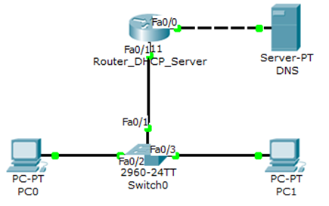

|  |  |  |  |  |  |
| --- | --- | --- | --- | --- | --- |
| **Device** | | **IP address** | **Subnet mask** | **Default Gateway** | **DNS address** |
| Router | Fa0/0 | 193.1.1.1 | 255.255.255.0 | - | - |
| Fa0/1 | 172.16.2.1 | 255.255.255.0 | - | - |
| PCs | | Dynamic (DHCP) | Dynamic (DHCP) | Dynamic (DHCP) | Dynamic (DHCP) |
| DNS Server | | 193.1.1.2 | 255.255.255.0 | 193.1.1.1 | - |

**Configuring a DNS server in Packet Tracer**

1. Select the service to configure

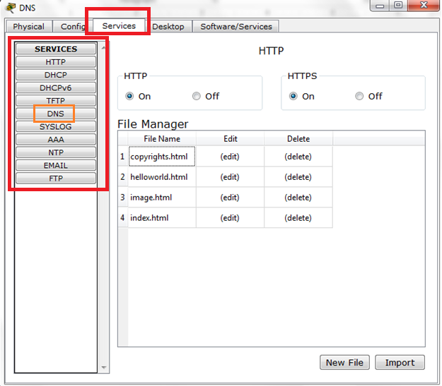

1. All the devices should have a DNS server address (verify you have assigned an DNS address using either DHCP service or statically assign the address)

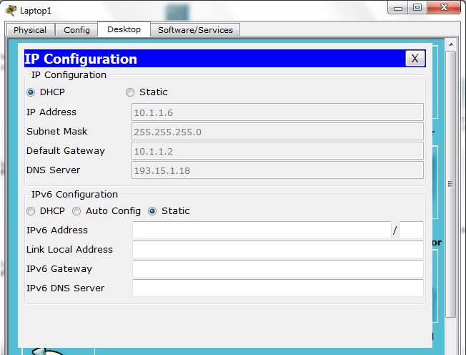

1. Add entries (Name and address)

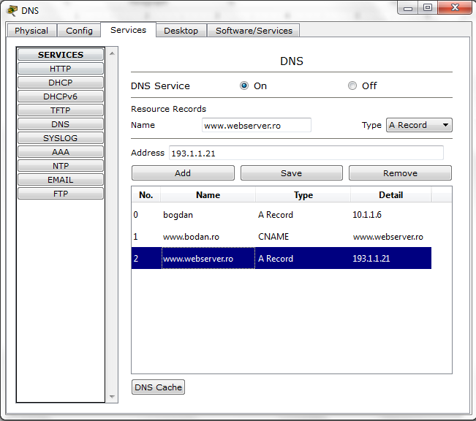

1. Test the DNS service:
   1. Open command prompt on a network host
   2. Enter the **nslookup** command
   3. Test with a define Name or IP address

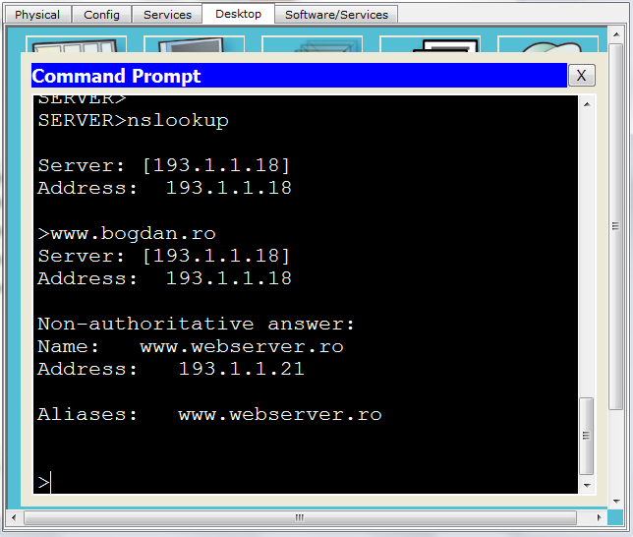

* 1. Ping/tracert the Name or the IP address